SELECT * FROM obat;

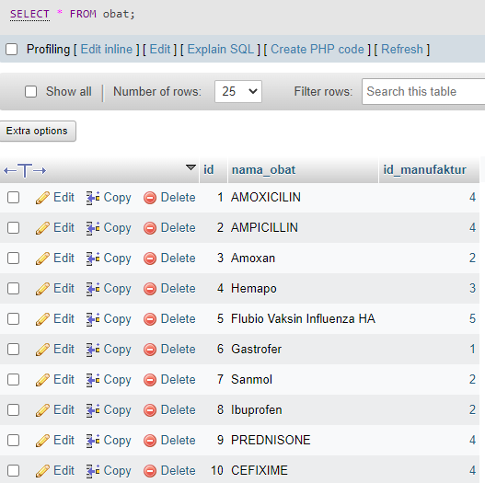

SELECT * FROM manufaktur;

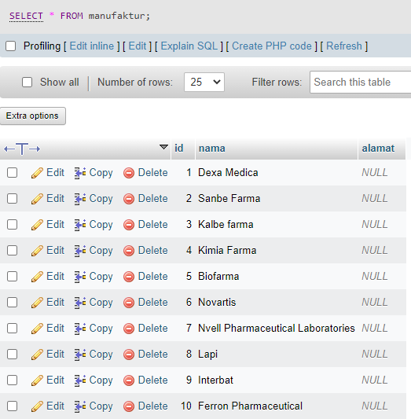

SELECT * FROM transaksi;

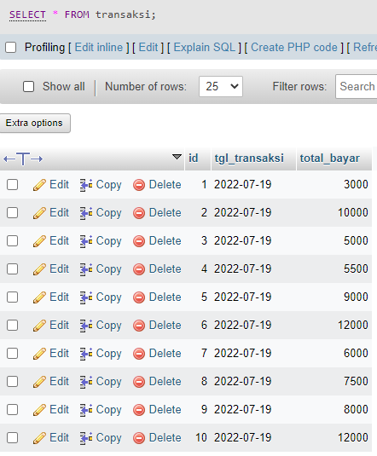

SELECT * FROM transaksi_detail;

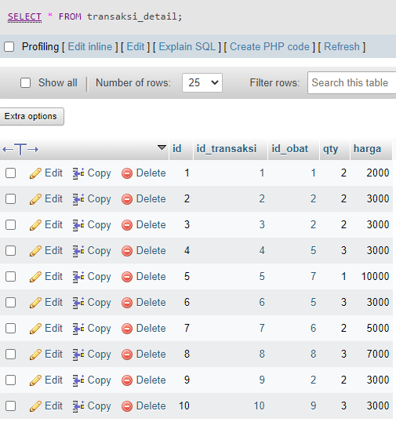

SELECT nama_obat FROM obat;

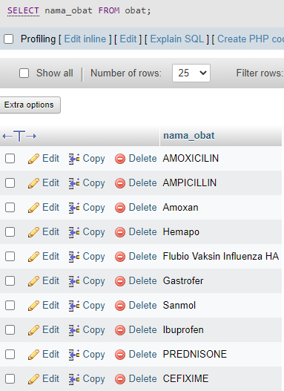

SELECT nama FROM manufaktur;

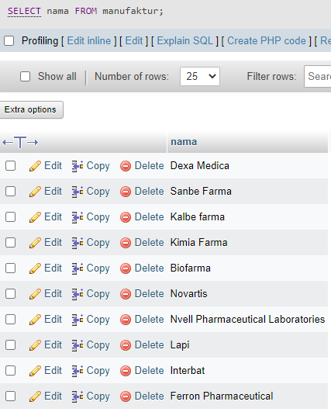

SELECT * FROM obat WHERE id_manufaktur = 1;

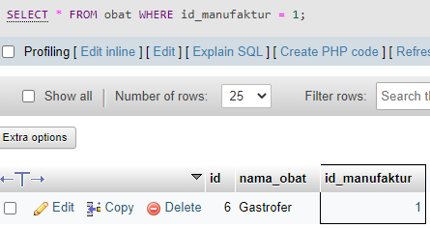

SELECT * FROM obat WHERE id_manufaktur = 4;

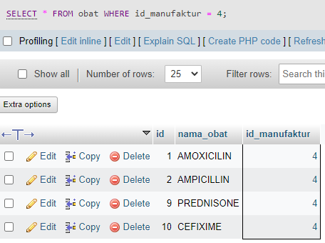

SELECT * FROM transaksi_detail WHERE harga > 3000;

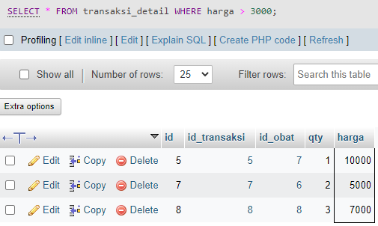

SELECT * FROM transaksi_detail WHERE qty > 2;

